Network IP: 181.167.148.0

Mask: 255.255.254.0 /23

X = 32 – 23 = 9 => 2^9 IPs = 512 IPs

**Given sub networks**

N1: 96 IPs

N2: 48 IPs

N3: 40 IPs

N4: 32 IPs

N5: 8 IPs

**Other sub networks**

N123: 3 IPs

N14: 2 IPs

N34: 2 IPs

N45: 2 IPs

N5w: 2 IPs

**N devices (IP) + 1 router + 1 NA + 1 BA => n + 3 required IPs for N1,N2,N3,N4,N5**

N1: 96 + 3 = 99 IPs <= 128 = 2^7 /25

N2: 48 + 3 = 51 IPs <= 64 = 2^6 /26

N3: 40 + 3 = 43 IPs <= 64 = 2^6 /26

N4: 32 + 3 = 35 IPs <= 64 = 2^6 /26

N5: 8 + 3 = 11 IPs <= 16 = 2^4 /28

**For sub networks N1234, N15 and N5w we need only 2 extra IPs**

N123: 3 + 2 = 5 IPs <= 8 = 2^3 /29

N14: 2 + 2 = 4 <= 4 = 2^2 /30

N34: 2 + 2 = 4 <= 4 = 2^2 /30

N45: 2 + 2 = 4 <= 4 = 2^2 /30

N5w: 2 + 2 = 4 <= 4 = 2^2 /30

**Total IPs**

128 + 64 + 64 + 64 + 16 + 8 + 4 + 4 + 4 + 4 = 360 < 512

N1=128, N2=64, N3=64, N4=64, N5=16, N123=8, N14=4, N34=4,N45=4, ,N5w=4

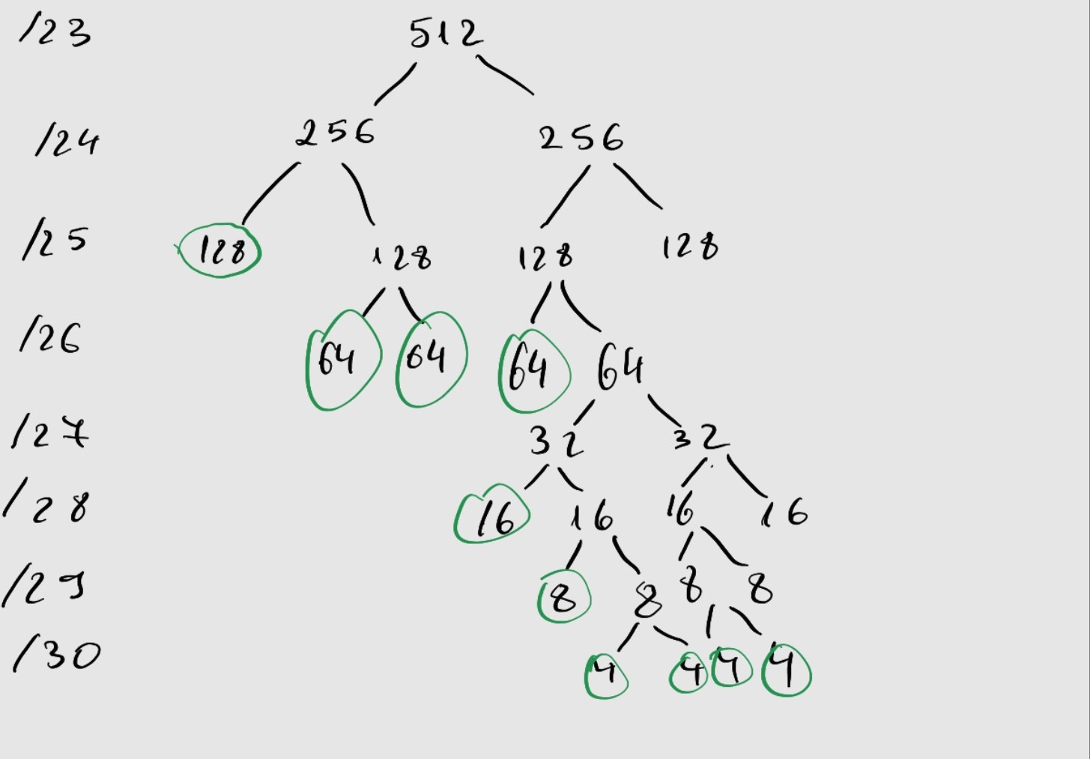

Enumerating the networks

N1 = 181.167.148.0/25 R1=.1, DHCP server = .2

N2 = = 181.167.148.128/26 R2=.129, WEB server = .130

N3 = 181.167.148.192/26 R3=.193, DNS server = .194

N4 = 181.167.149.0/26 R4=.1

N5 = 181.167.149.64/28 R5=.65

N123 = 181.167.149.80/29 R1=.81, R2=.82, R3 =.83

N14 = 181.167.149.88/30 R1=.89, R4=.90

N34 = 181.167.149.92/30 R3=.93, R4=.94

N45 = 181.167.149.96 /30 R4=.97, R5=.98

N5W = 181.167.149.100/30 R5=.101, Rw =.102